**DATA PREDICTION & EMOTION DETECTION USING NEURAL NETWORK**

**MAJOR**



**PROJECT**

**PHASE-3**



# SUBMITTED BY :-

Amit Sachdeva : 13103677(B8)

Abhinav Mishra : 13104757(B12)

Burhannudin Bhopalwala :13103735(B10)

# 

**TABLE OF CONTENTS**

**Chapter No. Topics Page No.**

Student Declaration II

Certificate from the Supervisor III

Acknowledgement IV

Summary V

**Chapter-1** **Introduction** Page No. 6 to Page No. 9

1.1 General Introduction

1.2 Problem Statement

1.3 Overview of proposed solution approach and Novelty/benefits

**Chapter-2** **Background Study** Page No. 10 to Page No. 17

2.1 Literature Survey

2.1.1 Summary of papers

2.2 Tabular comparison of existing approaches

2.3 Empirical Study

**Chapter 3: Analysis, Design and Modeling**  Page No. 17 to Page No. 28

3.1 Requirements Specifications

3.2 Functional and Non Functional requirements

3.3 Design Documentation

3.3.1Use Case diagrams

1. 3.2Domain Diagram

3.3.3 Sequence Diagram

3.4 Data Structure and Algorithm

**Chapter-4 Implementation and Testing** Page No. 29 to Page No. 34

* 1. Implementation details and issues
  2. Testing

4.2.1 Testing Plan

4.2.2 Component decomposition and type of testing required

4.2.3 List all test cases in prescribed format

4.2.4 Limitations of the solution

**Chapter-5 Conclusion & Future Work** Page No. 35 to Page No. 36

* 1. Conclusion
  2. Future Work

References Page No. 37

**II**

## DECLARATION

I/We hereby declare that this submission is our own work and that, to the best of my knowledge and belief, it contains no material previously published or written by another person nor material which has been accepted for the award of any other degree or diploma of the university or other institute of higher learning, except where due acknowledgment has been made in the text.

**Place: Signature:**

**Date: Name:**

(III)

**CERTIFICATE**

This is to certify that the work titled “**Data Prediction & Emotion Detection using Neural Network**” submitted by “**Amit Sachdeva, Abhinav Mishra and Burhanuddin Bhopal Wala**” in partial fulfillment for the award of degree of B.Tech (I.T.) of Jaypee Institute of Information Technology University, Noida has been carried out under my supervision. This work has not been submitted partially or wholly to any other University or Institute for the award of this or any other degree or diploma.

Signature of Supervisor ……………………….

Name of Supervisor: Dr. Satish Chandra

(Associate Professor)

**(IV)**

**ACKNOWLEDGEMENT**

I would like to extend our heartiest thanks and gratitude to the people who played a pivotal role in making our final year project a success and make it stand where it is now.

This was a vast project and required great expertise and it wouldn‟t have been possible without the arduous efforts of my mentor Dr. Satish Chandra who helped us in every little way possible to implement our thoughts.

Signature of the Student ……………………..

Name of Student Amit Sachdeva

……………………

Abhinav Mishra

………………………………….

Burhanuddin Bhopal Wala

(V)

**Summary**

The thrust of this project is to highlight the practical treatment of Asperger’s Syndrome through emotion detection application. We have proposed an implementation for its treatment through an android application. Through our proposed application, any child with this disorder can learn about different emotion practically by detecting the emotion of a person, they are not able to comprehend.

We have studied the problem associated in the treatment of Asperger Syndrome and came to know that affect person is not able to comprehend the emotions. So we came out with an application that detect emotions and tries to improve the social skills of affected child. We have used some computer vision libraries like opencv, face++ for the implementation of this application

Chapter-1

Introduction

**1.1 General Introduction**

Asperger’s syndrome (also known as Asperger’s Disorder) was firstly discovered in 1940’s. It can be type of Autism. It often said that they cannot properly understand other’s emotions. In this project we have proposed an android application and desktop application that will help in Asperger syndrome and try to solve the emotion detection problem for the people suffering from it.

Here we have implemented artificial neural network, unlike conventional image-processing systems. Basically neural network means that each neuron is connected to main neuron to transfer data. Similarly in artificial neural network, it is divided into 3 parts input, hidden layers and output.

This time we try to improve efficiency of our project by improving our image quality by using noising and DE noising of image through Gaussian method and NLM method. Here we are also using DE blurring method to improve image quality.

Image Denoising**(**is operation specifically removing specific noise( dirty pixels) from source data set**)** and Deblurring(method of replacing all the dirty bits/pixels with new pixels). To check that our results is right we have used image slide show to check whether person response according to type of images show in slide show.

## 

## 1.2 Problem Statement

# Thrust of the project is to highlight the practical treatment of ASPERGER‘s SYNDROME through emotion detection application and artificial neural network with improving efficiency of image.

## 1.3 Overview of proposed solution approach and Novelty

Our main aim is to detect emotion of the person using our application whether person is crying, laughing etc. So with this thought we proposed a creation of an application that has following features: Face Detection: To detect the face of person, so that training of image of face can be done for further processes. Face Recognition: To recognize the face with the help of previous stored data, this will help the patient to keep on interacting with the people around him. Emotion Detection: To detect different emotion of human beings and provide the output describing the details of that emotion. Side by side we are denoising image using Gaussian method for Gaussian noise and NLM method for impulsive noise. This lead to improve efficiency of image and we get better results. Every data update dynamically at each test case to improve efficiency with each test case.

Chapter-2

## Background Study

### 2.1 Literature Survey

**2.1.1 Research Paper 1**

* **Title : Deblurring and Denoising of Magnetic Resonance Images using Blind Deconvolution Method**
* Author : Arunabha Debnath, Hari Mohan Rai, Chahat Yadav, Anjali Agarwal & Ankit Bhatia
* Year of Publication: 2013
* Place of Issue: International Journal of Computer Applications (0975 – 8887)

**Summary:** This paper describes the methods to improve the quality of blurred image of MRI machine due to motion artifact. Main objective to get original image from motion blurred image due to lack of optical focus. So we used Blind deconvolution method has been applied to restore the clear image because other methods are not that effective. This method give sharp image from blurred image and in case of MRI we always require sharp images as we cannot compromise on the health of the patient. The aim of this paper is to study theortically and practically for deblurring of image in which it read Gaussian noise and blurred images and deblur them.

**2.1.2 Research Paper 2**

* **Title :** **Fast Gradient-Based Algorithms for Constrained Total Variation Image Denoising and Deblurring Problems**
* Author : Amir Beck and Marc Teboulle
* Year: NOVEMBER 2009
* Place Of Issue: IEEE TRANSACTIONS ON IMAGE PROCESSING

**Summary:**

This paper revolves around denoising and deblurring problems based on total variation minimization model with constraints. We derive fast algorithm for the constrained TV based image and denoising problem fast iterative with monotone of FISTA. The gradient base algorithm shares a remarkable proven global known gradient projections model. Results applicable to isotropic tv ftnls, numerical results demonstrate viability and proposed algorithm on deblurring with box constraints.

**2.1.3 Research Paper 3**

* + **Title: Robust flash denoising/deblurring by iterative guided filtering**
  + Author: Hae-Jong Seo1 and Peyman Milanfar
  + Year: 2012
  + Place of Issue: Seo and Milanfar EURASIP Journal on Advances in Signal Processing

**Summary**: A practical problem addressed recently in computational photography is that of producing a good picture of a poorly lit scene. Our approach involves two images and merge flash produces turning the flash produced an image (SNR).

Our method generalize of guided filter approach in particular analyze the guided kernel matrix formulation and novel iterative application of the guided filter. A nonlinear anisotropic and reaction diffusion of noisier image. Results are combined in an unsupervised manner. Proposed outperforms for both flash denoising and deblurring.

**2.1.4 Research Paper 4**

* **Title: Image Denoising and Deblurring Using Non-Local Means Algorithm in Monochrome Images**
* Author: N. Hemalatha
* Year: Feb-Mar 2014
* Place of Issue: International Journal of Engineering Research and General Science Volume 2, Issue 2

**Summary**: Image deblurring and denoising are the fundamental problems image processing with several applications. This paper areas of image restoration. Image deblurring and Impulsive noise is a most common noise which affects the image quality during image acquisition, process in the area of image denoising. Impulsive noise can be categories into two. Image deblurring methods are most commonly designed for Gaussian noise. The proposed work impulsive noise and Gaussian noise from images. Removal of impulsive noise is carried out i.e. detecting the noise and also followed by filtering. The numerical results will confirm that proposed methods yields the better performance, in the terms of PSNR (Peak Signal to Noise Ratio).

**2.1.5 Research Paper 5**

* **Title** **Image deblurring and denoising with non-local regularization constraint**
* Author: P. van Beek, J. Yang, S. Yamamoto and Y. Ueda
* Year: January 2010
* Place of Issue Visual Information Processing and Communications 2010, Proc. SPIE vol. 7543, eds. A. Said and O. Guleryuz, San Jose, CA

**Summary:**

In this paper, we investigate the use of the non-local means (NLM) denoising of image deblurring and restoration. We propose a novel deblurring approach that regularization constraint. Our interest in the NLM potential preserving edges and texture detail. Our approach leads to an iterative cost function minimization algorithm, but incorporating update terms due to the non-local regularization constraint. The data adaptive noise on denoised and deblurred result. We compare algorithm to conventional deblurring methods, including deblurring with total variation (TV) regularization. We also compare our algorithm to combinations of NLM-based ﬁlter followed by conventional deblurring methods.

**2.1.5 Research Paper 5**

* + **Title - Image based Face Detection and Recognition**
  + Author - Faizan Ahmad, Aaima Najam and Zeeshan Ahmed
  + Year of publication - November 2012
  + Place of Issue :- IJCSI International Journal of Computer Science Issues
  + Link- <http://arxiv.org/abs/1302.6379>

**Summary** - Face recognition from image or video is a popular topic in biometrics research. It is widely acknowledged that the face recognition have played an important role in surveillance as it doesn’t need the object’s cooperation. As human face is a dynamic degree of variability in its appearance, detection a difficult problem in computer vision. In this speed of identification is a main issue. In current paper they developed for the said method’s evaluation as a first milestone for video based face detection and recognition for surveillance.

* 1. **Research Paper 6**
  + Title - Facial Emotion Recognition with a Neural Network Approach
  + Author :- Wathsala Nayomi Widanagamaachchi
  + Year Of Publication - August 2009
  + Place Of Publish - University of Colombo School of Computing
  + Link- <http://unnaderzo.netne.net/q/164.html>

**Summary** - Many factors contribute in conveying emotions of an individual. Pose, speech, facial expressions, behavior and actions are some of them. From these above mentioned factors facial importance since they are easily perceptible. To obtain their approaches by either using less feature points or by using a neutral image of the person in the phase. If we can address this problem from an identified set of critical feature points and feature detection techniques the overall performance can be augmented. Facial expressions can be systems meant for children with brain development disorders are some other beneficiaries.

**2.1.7 Research Paper 7**

* + - Title of paper - Eigenfaces for Recognization
    - Author - M turk ,A Pentland
    - Year of publication:- 1991
    - Place of publication :- Journal of cognitive neural science
    - Link - <https://scholar.google.com/citations?user=KltleWgAAAAJ>

**Summary** - Edge and feature points are basic low level primitives for image processing. Edge and feature detection are two of the most common operations in image analysis. An edge in anwhich the brightness abruptly. In image processing, an edge is often interpreted as one class of singularities. In a function. However, image often are defined as the Local maxima of the gradient. Operations in image processing, this topic has and many achievements have been made. For Such as: Rooms et al proposed to estimate the out of focus blur in wavelet domain by examining the sharpness of the sharpest edges.

**2.1.8 Research Paper 8**

* + Title - feature extraction using PCA
  + Author - Vincent
  + Year of publication – 2014-15
  + Link - http:// [www.visiondummy.com/2014 /05/](http://www.visiondummy.com/2014%20/05/)

**Summary** - In the field of Image processing there are many techniques to detect edges. Some of the methods are ‘First derivative method’, ‘Second derivative method’, Sobel, Laplacian of Gaussian (Log) and of detecting edges through Artificial Neural Networks (ANN) has been proposed. Experimentation is performed on gray scale image, second derivative and Sobel operator. Edge detection is an. It can be used in many applications such as segmentation, registration of objects in a scene.

**2.1.9 Research Paper 9**

* + A Computational Approach to Edge Detection By john canny
  + Link- <http://ieeexplore.ieee.org/document/4767851/>

**Summary-** This paper describes a computational approach to edge detection. The success of the approach depends on the definition of a comprehensive set of goals for the computation of edge points. These goals enough to delimit the desired behavior of the detector as functional on the operator impulse response. We use the criteria in numerical optimization to derive detectors for several common image features, including step edges. On between which are the two main goals. With this principle we derive a single operator shape which is optimal at any scale. The optimal detector has a implementation in which edges are marked at maxima in gradient magnitude of a Gaussian-smoothed image.

**Research Paper: 10**

**Algorithm flow: (Initial Face Detection Techniques Used in Phase 1)**

1) Divide the color image into its constituent Red, Green and blue component

Matrices using OPEN CV.

For each separate channel i.e. Red, Green and Blue perform the following

2) Calculate the histogram of individual matrices.

3) Repeat for **1 to n** // where n is the total no of different pixel intensity present//

Multiply and accumulate a type of pixel intensity with its number of occurrence.

End

4) Repeat step 3 for red, green and blue matrices.

5) Divide step 3 with the total no of pixels present in a particular matrix to calculate the

Threshold for it.

6) Construct the binary image for each **R, G, and B.**

7) Add the similar pixel positions for each RGB**.Σ (Rij+Gij+Bij) i=1 to m and j= 1 to n,**

Where **m** and **n** are the total no of rows and columns…

8) If summation is less than 1 set

“Face Detected”

Else

“Face Not Detected”

**Research Paper: 11**

**Algorithm flow: (Face Detection Algorithm Technique Used in Final Phase, Technique Using Eigen Faces and Eigen values)**

We use principal component analysis with “Eigen face” approach due to its simplicity, speed and learning capability. The design of the face recognition system is based upon “Eigen faces”. The original images of the training set are transformed into a set of Eigen faces E. Then, the weights are calculated for each image of the training set and stored in the set upon observing an unknown image Y, the weights are calculated for that particular image and stored in the vector WY. Afterwards, WY is compared with the weights of images, of which one knows for certain that they are facing.

**1 :** We make use of Eigenvectors and Eigenvalues for face

Recognition with PCA. So we prepare an initial set of

Face images [X1, X2... Xn]. The average face of the

Whole face distribution is X = (X1 + X2 + ... + Xn)/n

Then the average face is subtracted from each face,

Xi' = Xi - X, i = 1, 2... n.

[Y1, Y2... Yn] eigenvectors are calculated from the

New image set [X1', X2’ ... Xn'].

[Y1, Y2... Yn] eigenvectors are calculated from the

New image set [X1', X2’ ... Xn']. These eigenvectors are

Orthonormal to each other. These Eigen faces look like

Sort of face they do not correspond directly to any face

Features like eyes, nose and mouth. Comparing with new

Image Set **DETECTING THE FACE FINALLY .**They are a set of

Important features which describe the variation in the

Face image set.

Figure no. 1



*Why used this method continue ;*

Under static mode, where recognition is performed on

Single scaled images without rotation, a recognition

Accuracy of 96% has been achieved. Face location and

Normalization were performed in real-time and

Consistent accuracy in face detection is recorded with video input.

**Research Paper 12:**

**Advance Technique / Method for detecting the faces using Eigen Faces and Eigen Values:**

Why this Advance Technique:

*We develop an improved recognition strategy based computational model to identify the face of an unknown person. The proposed computational model makes use of the well-known Eigen faces approach training set of vectors and are used to identify an unknown face. The feature vector of the unknown face is compared with vectors in the database using the improved recognition strategy described in this paper.*

//Algorithm for this:

The proposed is based on the well-known Eigen faces. In mathematical terms, we wish to find the principal of faces, or the eigenvectors of the covariance matrix of the set of face images, treating an image as a point (or vector) in a high dimensional space characterize the variation between face images. Each image location contributes more or less to each eigenvector, so that we can display the eigenvector as a sort of ghostly face which we call an Eigen faces.

1: Calculating the, Eigen Values of the Faces through well-defined functions, for all the faces inside the Training Set. {X1, X2, X3, ----------------------- Xn };

2: Then Taking the Average of the Eigen Values let’s say X, which is equal to the training set {X = X1+X2----------------Xn / N (number of faces)};

3: Taking the difference of the Eigen Values of the X’ (to be find for) – X;

4: If X’ > X, then Face is not detected!!

If X’ == X then Evaluate Again;

If X ‘< X then the face is detected!!!

5: Then finally save that Image to, Updating the Eigen Values Average X and with the addition of X’ in the Database.



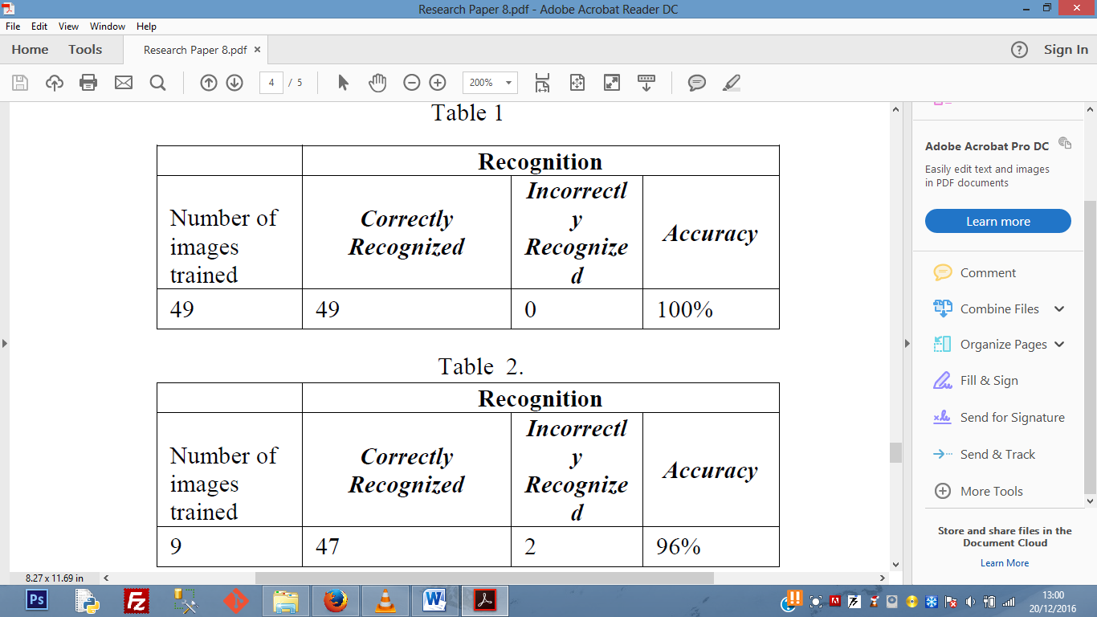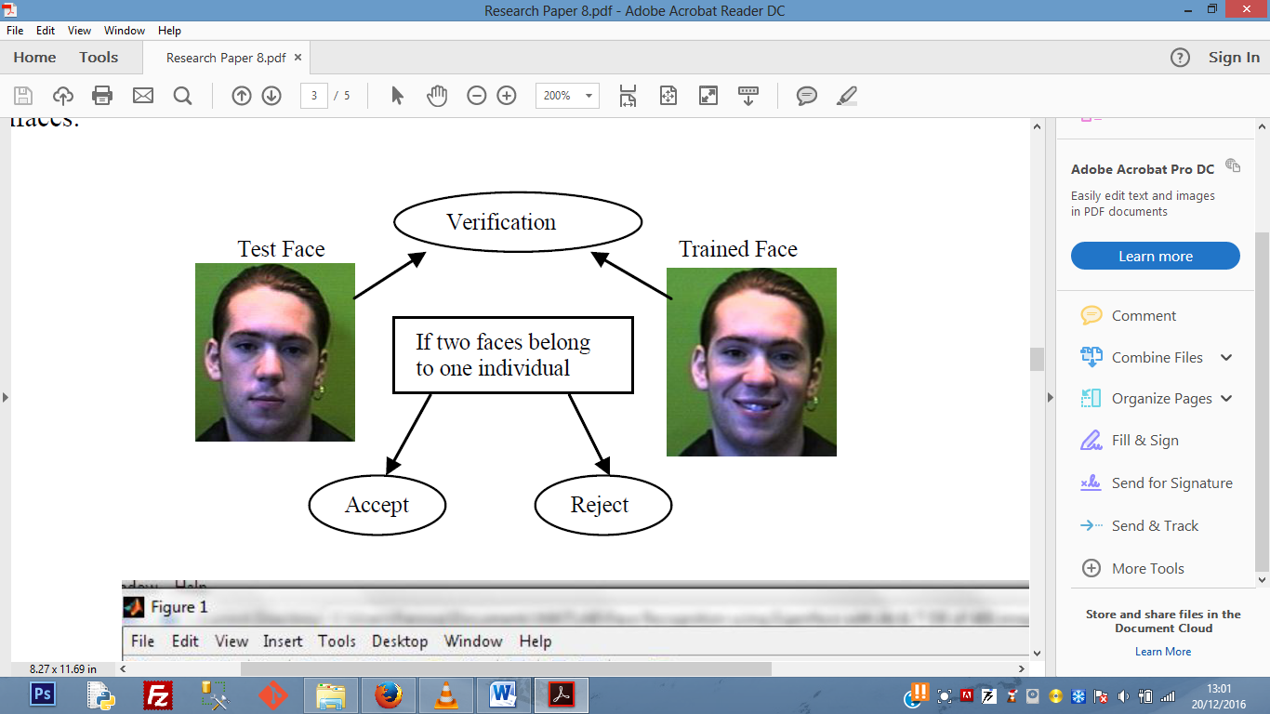

### Empirical Study

**2.2.1 PROPOSED DENOISING ALGORITHM**

Gaussian noise is equally distributed over the signal. Impulsive noise is denoted by changing part of an image pixel with noisy values, this noise affects image pixel by pixel not the whole area of an image. Such noise is introduced during an acquisition process or due to transmission errors. Impulsive noise can be classified as fixed valued impulse noise and Variable type impulse noise .An image containing noise can be described as follows:

x(i,j) = η i,j probability p

y i,j probability 1− p (1)

where x(i, j) denotes a corrupted image pixel, y(i, j) denotes a uncorrupted image pixel and η(i, j) denotes a corrupted pixel at the location (i, j).In fixed value impulse noise, corrupted pixels take either minimum or maximum values i.e. η(i, j) ∈ {Nmin, Nmax }, and for variable type impulse noise,(i.e.,RVIN) corrupted pixels take any value within the range minimum to maximum value i.e., 𝜂i,j ∈ [Nmin, Nmax ] ,where Nmin and Nmax denote the lowest and the highest pixel values within the specified range respectively .

**2.2.2** **Non-Local Means Filtering (NLM)**

Basically, the NL-means filter estimates an uncorrupted intensity as average weighted for all pixel in the image, and the weighted value are proportional to the similarity between the neighbor pixel value being processed and the surrounding pixels of neighbor pixels. However, these nonlocal means filtering method are very efficient in preserving image details when denoising. This filtering method also to remove combination of impulse and Gaussian noise. The best solution could be to locally varying parameters, so that they are primely tuned to remove the particular amount and various noises present in each part of the image.

**2.2.3 DEBLURRING ALGORITHM**

Image deblurring is the exercise of processing the whole image to view it a better representation of the section. In this process of restoring the original sharp image a mathematical model of the blurring is used. So, first a mathematical model is devised that relates, the given blurred image to the unknown true image. Image Deblurring techniques are sensitive to noise, yet a small amount of noise, which is unavoidable in low-light conditions, can disintegrate the quality of gaussian blur kernel estimation dramatically. Iteratively deblur and denoised, a blurry and noisy image. However, directly applying image denoising methods often slightly damages the blur information that is removed from the original image, leading to kernel estimation. A new method is proposed for handling noise in image deblurring based on new theoretical and practical insights. The key observation is that applying an iterative filtering process, so that the noise level in an image get greatly reduces, while preserving the blur information in the statiscally independent direction to the filter. A nonlocal self similarity constraint is combine with non-locally centralized sparse representation (NCSR) is proposed. The proposed image deblurring methods are effective in restoring image structures from blurred image data. However, they tend to over smooth the local image details. This drawback is overcome by combining iterative shrinkage regularization with a NL self-similarity constraint, which helps to sharpen image edges and restore the fine details. Experimental results validate the performance of the proposed approach in both evaluation indexes and visual quality. As mentioned in Table II and Table III, that our algorithm achieves higher performance quality results than existing methods on blurry and noisy images.

**2.2.4 Canny Edge Detection Algorithm-**

**Canny edge detection** also known to many as the *optimal detector*, canny algorithm aims to satisfy three main criteria:

* **Low error rate:** Meaning a good detection of only existent edges.
* **Good localization:** The distance between edge pixels detected and real edge pixels have to be minimized.
* **Minimal response:** Only one detector response per edge.

The Algorithm consists of the following steps:

1. Noise reduction. May be performed by [Gaussian filter](http://en.wikipedia.org/wiki/Gaussian_blur).
2. Compute intensity gradient (matrices {\displaystyle G_{x}}Gx and {\displaystyle G_{y}}Gy) and its magnitude {\displaystyle G}G.

   {\displaystyle G={\sqrt {G_{x}^{2}+G_{y}^{2}}}}  
May be performed by [convolution of an image](https://rosettacode.org/wiki/Image_convolution) with [Sobel operators](http://en.wikipedia.org/wiki/Sobel_operator).



1. Non-maximum suppression. For each pixel compute the orientation of intensity gradient vector (theta): {\displaystyle \theta ={\rm {atan2}}\left(G_{y},\,G_{x}\right)}

   {\displaystyle G\left(p_{a}\right)<G\left(p\right)<G\left(p_{b}\right)}   
where {\displaystyle p} is the current pixel p, {\displaystyle p_{a}} and Pa, Pb {\displaystyle p_{b}} are the two neighbour pixels in the direction of gradient, then {\displaystyle N(p)=G(p)}, N(p) = G(p) otherwise N(p) = 0 {\displaystyle N(p)=0}. Nonzero pixels in resulting array correspond to local maxima of G{\displaystyle G} in direction of theta (p){\displaystyle \theta (p)}.



Tracing edges with hysteresis. At this stage two thresholds for the values of G, Tmin and Tmax are introduced: {\displaystyle T_{min}}*Hysteresis*: The final step. Canny does use two thresholds (upper and lower):

1. If a pixel gradient is higher than the *upper* threshold, the pixel is accepted as an edge
2. If a pixel gradient value is below the *lower* threshold, then it is rejected.
3. If the pixel gradient is between the two thresholds, then it will be accepted only if it is connected to a pixel that is above the *upper* threshold.

**2.2.5 HaarCascade feature extraction –**

**Haar-like features** are [digital image](https://en.wikipedia.org/wiki/Digital_image) [features](https://en.wikipedia.org/wiki/Feature_(computer_vision)) used in [object recognition](https://en.wikipedia.org/wiki/Object_recognition). They owe their name to their intuitive similarity with [Haar wavelets](https://en.wikipedia.org/wiki/Haar_wavelet) and were used in the first real-time face detector. working with only image intensities (i.e., the [RGB](https://en.wikipedia.org/wiki/RGB) [pixel](https://en.wikipedia.org/wiki/Pixel) values at each and every pixel of image) made the task of feature calculation [computationally expensive](https://en.wikipedia.org/wiki/Computationally_expensive). A simple rectangular Haar-like feature can be defined as the difference of the sum of pixels of areas inside the rectangle, which can be at any position and scale within the original image. Object Detection using Haar feature-based cascade classifiers is an effective object detection method proposed by Paul Viola and Michael Jones in their paper, "Rapid Object Detection using a Boosted Cascade of Simple Features" in 2001. It is a machine learning based approach where a cascade function is trained from a lot of positive and negative images. It is then used to detect objects in other images.

Here we will work with face detection. Initially, the algorithm needs a lot of positive images (images of faces) and negative images (images without faces) to train the classifier. Then we need to extract features from it. For this, haar features shown in below image are used. They are just like our convolutional kernel. Each feature is a single value obtained by subtracting sum of pixels under white rectangle from sum of pixels under black rectangle.

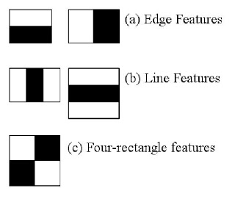

Chapter 3:

### Analysis, Design and Modeling

**‘’3.1 Core Requirements -**

#### **3.2 Functional and Non Functional requirements**

**3.2.1 Functional Requirements –**

**1.** Noising and Denoising:

In phase 3, our main target to denoise image using Gaussian method and NLM method and real image which is detected after webcam start and then improper image is denoised.

**2.** Deblurring Image:

Image deblurring is the exercise of processing the whole image to view it a better representation of the section. In this process of restoring the original sharp image a mathematical model of the blurring is used. In our Project, we are try to deblur to clear the image so that it will improve the efficiency.

**3**. Camera and Gallery access:

Our first task is to get media access. To detect an object instantly we need the camera access and if we want to choose an image from our local storage then we need the gallery access.

**4**. Face Detection:

Once we got the camera and gallery access we will capture/select the image now the next task is to detect the faces from given image. We have used google API to detect the face.

**5.** Feature extraction:

From a given object(face) now we want to extract its features using Haar cascade feature extraction. We have implemented the concept of Eigen value to get feature vector.

‘

**6**. Emotion detection:

Once we get the co-ordinate of face rectangle our next requirement is to detect the emotion. We have applied canny edge emotion detection algorithm to detect the emotion.

**3.2.2 Nonfunctional Requirements**

Functionality:

Additional features for security will be enabled through the use of a OpenID and OAuth through a third-party library features are the ability to encrypt and store passwords, provide recovery options for users that have forgotten their password, and store a cookie to validate the session.

Usability:

A key point in the design of this application is ease of use and appeal to the users. The application should be consistent across multiple platform paradigms.

Reliability:

In order to ensure that there is no confusion to the user in the case of the internet or server failure. If Internet failure occurs app will keep your data safe in your local storage device.

Performance:

In order to have a great performance, the application should be as lightweight as possible by keeping hardware demands to a minimum on both the client and server sides.It gives high performance even if there exist multiple objects. It detects object in worst case also when image is blur. Canny edge give more than 90% efficiency.

3.3 Design Documentation

* 1. **Neural Network Model-**

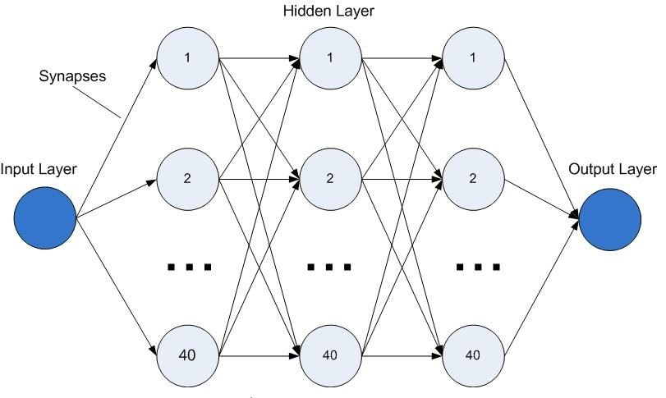

* 1. **Project Structure-**

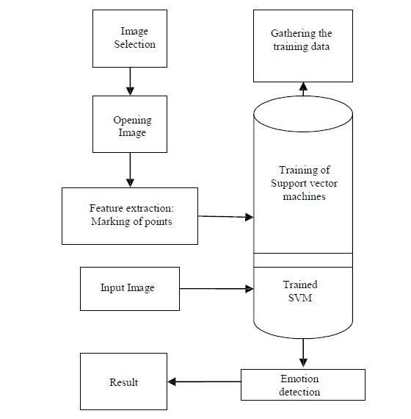

Data Structures

In the implementation of the system these data structures are used to store pixels, Eigen’s values and Eigen’s vectors ArrayList, Vector, Binary Tree, Fibonacci Heap and the Hash Map.

**ArrayList-** the ArrayList class has random read capability just like an array, but it also has the capability to grow inventively just like a linked list. Hence we will be using the ArrayList to keep track of the positions pixels .using array list we can add and pull the values very frequently. Following are the operations performed on ArrayList - pixels.add(new Pixels()); Pixel part = pixel.get(0); part.display(); pixel.remove(0); particles.size();

**Vector-** Vectors are much like arrays. Like arrays, **vector data** is allocated in contiguous memory. Unlike arrays, which are always of a fixed size, **vectors** can be grown. We have stored the eigen’s vectors in form of vector. Main advantage of vector is Data can be represented at its original resolution and form without generalization. Accurate geographic location of data is maintained. The location of each vertex needs to be stored explicitly.

Vector fdt = new vector (CenterOfMouth.x – EyeLeftCorner.x), (CenterOfMouth.y – EyeLeftCorner.y))

**Quad Tree-** We have implemented Quad Tree to divide our image into sub images or in the form of small pixels.Here we will outline the strategy behind using quad trees as a data structure for pictures. The key is to "Divide and conquer". To represent a picture using a quad tree, each leaf must represent a uniform area of the picture. If the picture is black and white, we only need one bit to represent the color in each leaf; for example, 0 could mean black and 1 could mean white.

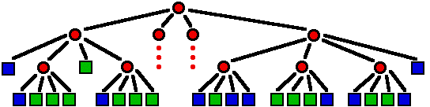

**Binary Tree-** Binary Tree is a special data structure used for data storage purposes. A binary tree has a special condition that each node can have a maximum of two children.

**Fibonacci Heap - This is an important data structure for the evaluation of eigen values and vectors. We have implemented this for** extracting the minimum and maximum value of eigen value vec and r b val.. which we alter use for face detection and feature extr.

4.1 Implementation and Issues:-

Computer Application:-

In our project we have detect emotion of asperger syndrome person using harcassade and Artificial Neural Network. As each person different face structure so our whole application is divided into two portion: - Training Set and Testing Set. Firstly we run a loop of 3 to train our machine and its result will be used for further testing. In Testing we run a loop of 50 which will tell that person is smiling or shocked on basis of testing set taken in account of training set. In training set eyes and mouth are detected and then mouth size is divided with face size and similarly with eyes size with mouth size and then take average of all case. Then we run loop of testing set and compare the mouth/face ratio which trained ratio, if ratio is greater than trained ratio than smiling else not. We save whole results in array and then find out percentage= (array*100)/total length of loop. We have use Tkinter to run application. For each person separate folder is created in which his images are saved and its whole result of mouth and eyes are saved in different text. Final result are saved in different text using append mode. Person if laughing is not shocking and vice versa. So at final we tell how much percentage person is shocking or not.

ISSUES: - Opencv used not work in sunlight and for heavy lips mouth. Opencv also detect multi mouth and eyes at single time.

Solution: - As mouth comes after half of face and then we check size of face and check if mouth is detected after half of face. And Avoid Extra detection of eyes. We avoid sunlight and use normal light for face detection.

PHASE 3:

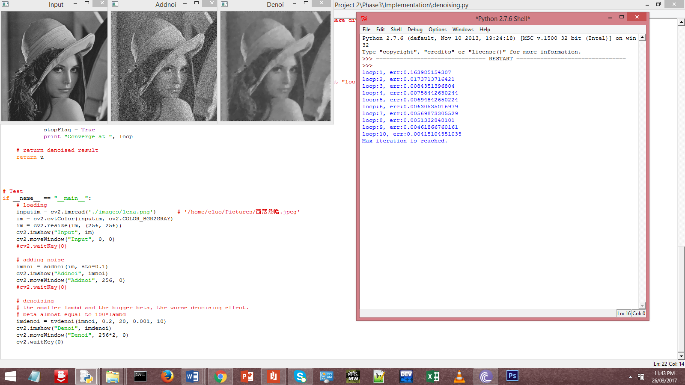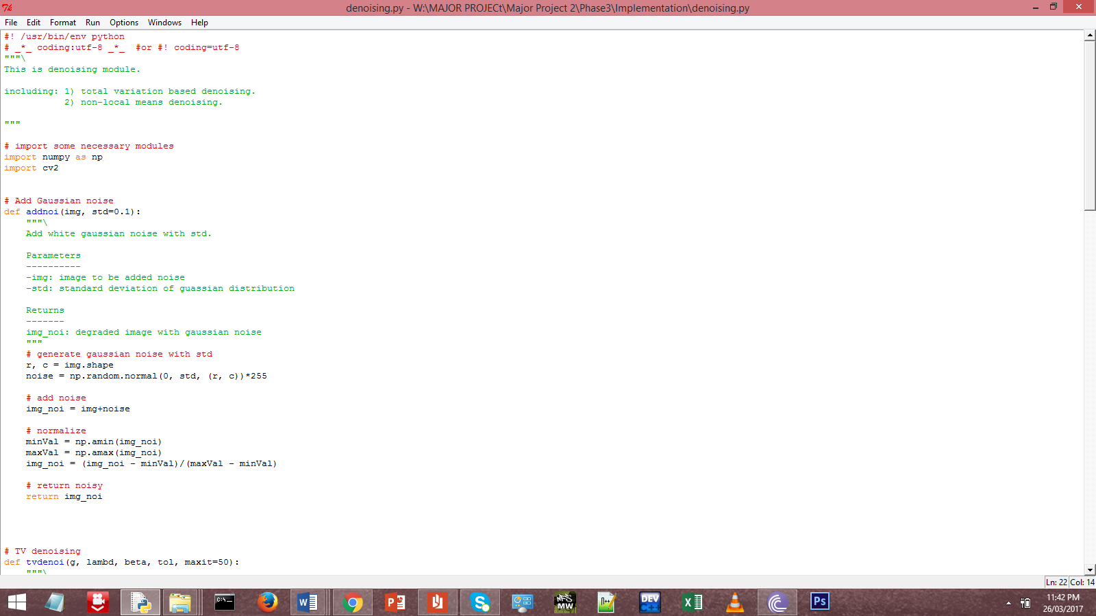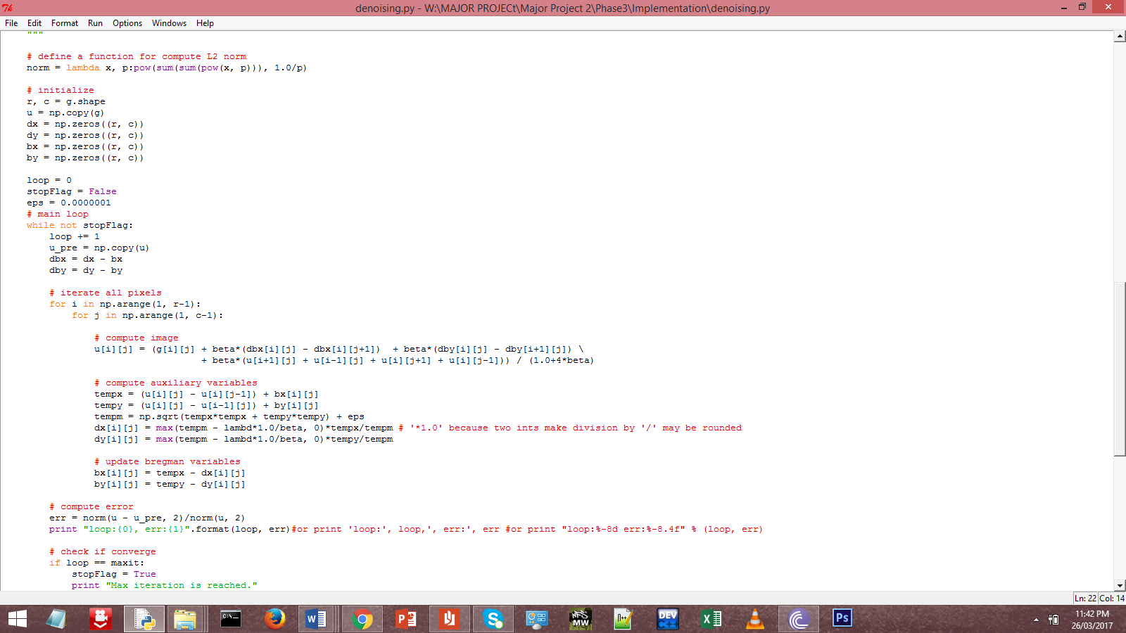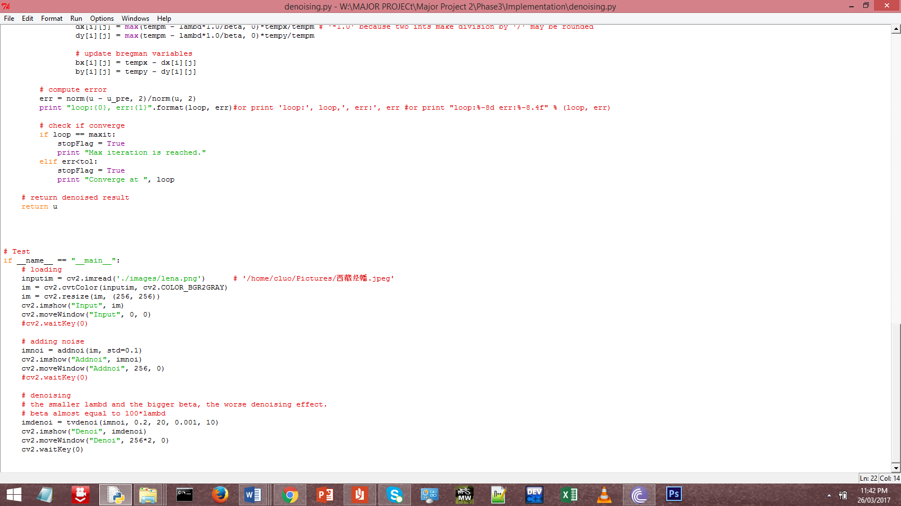

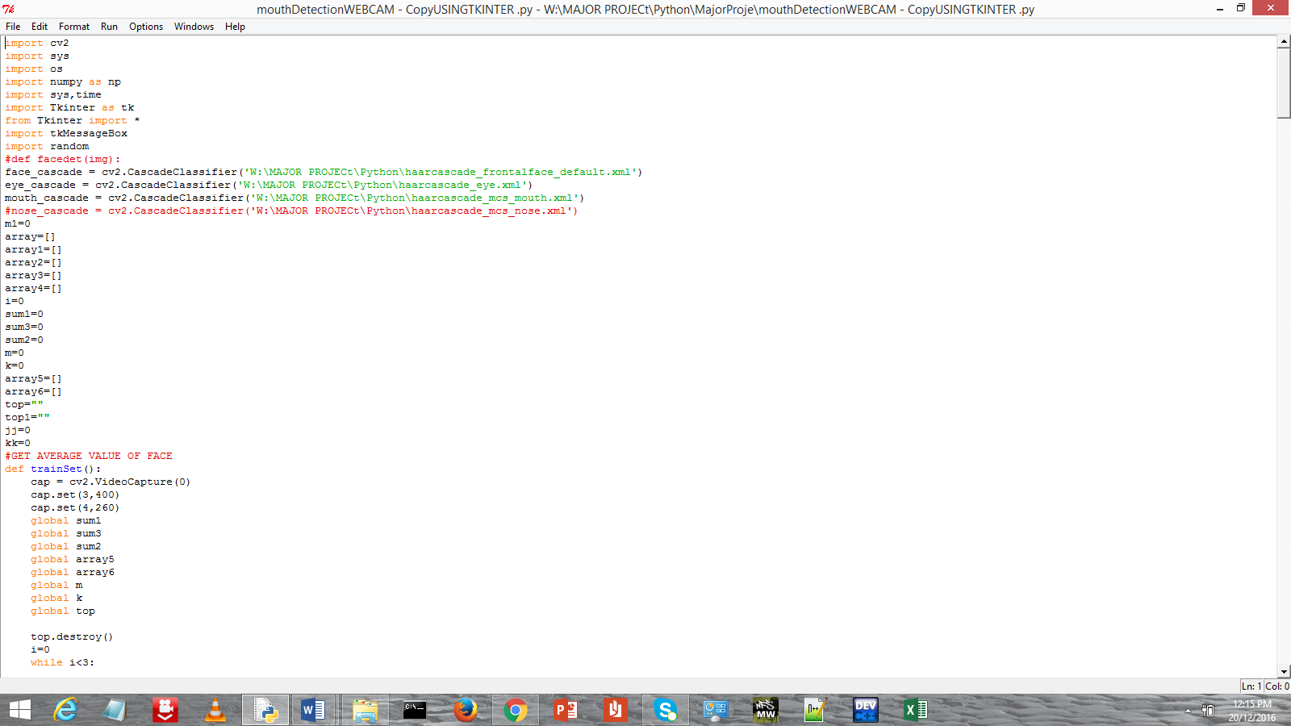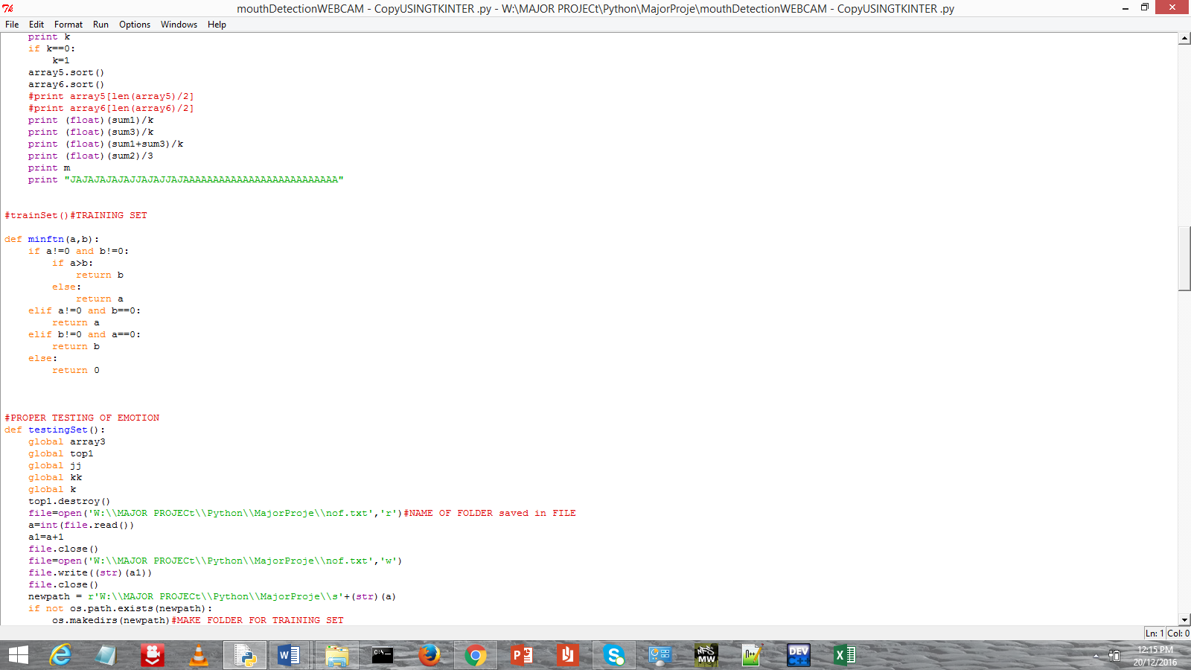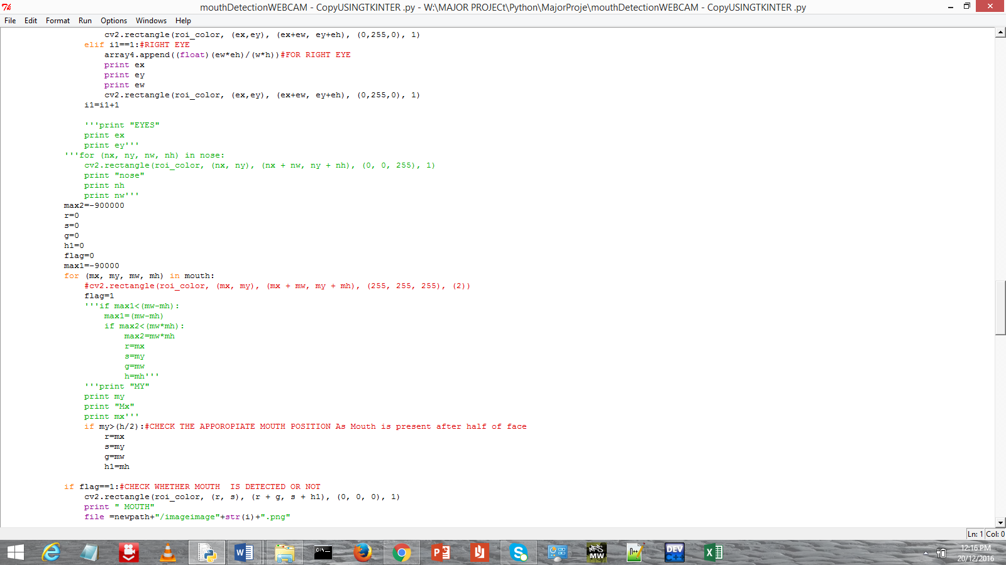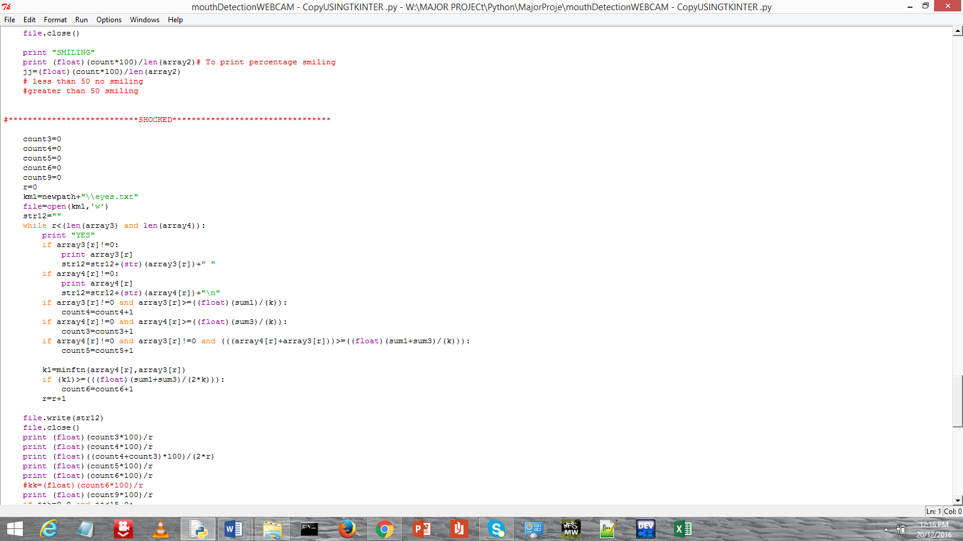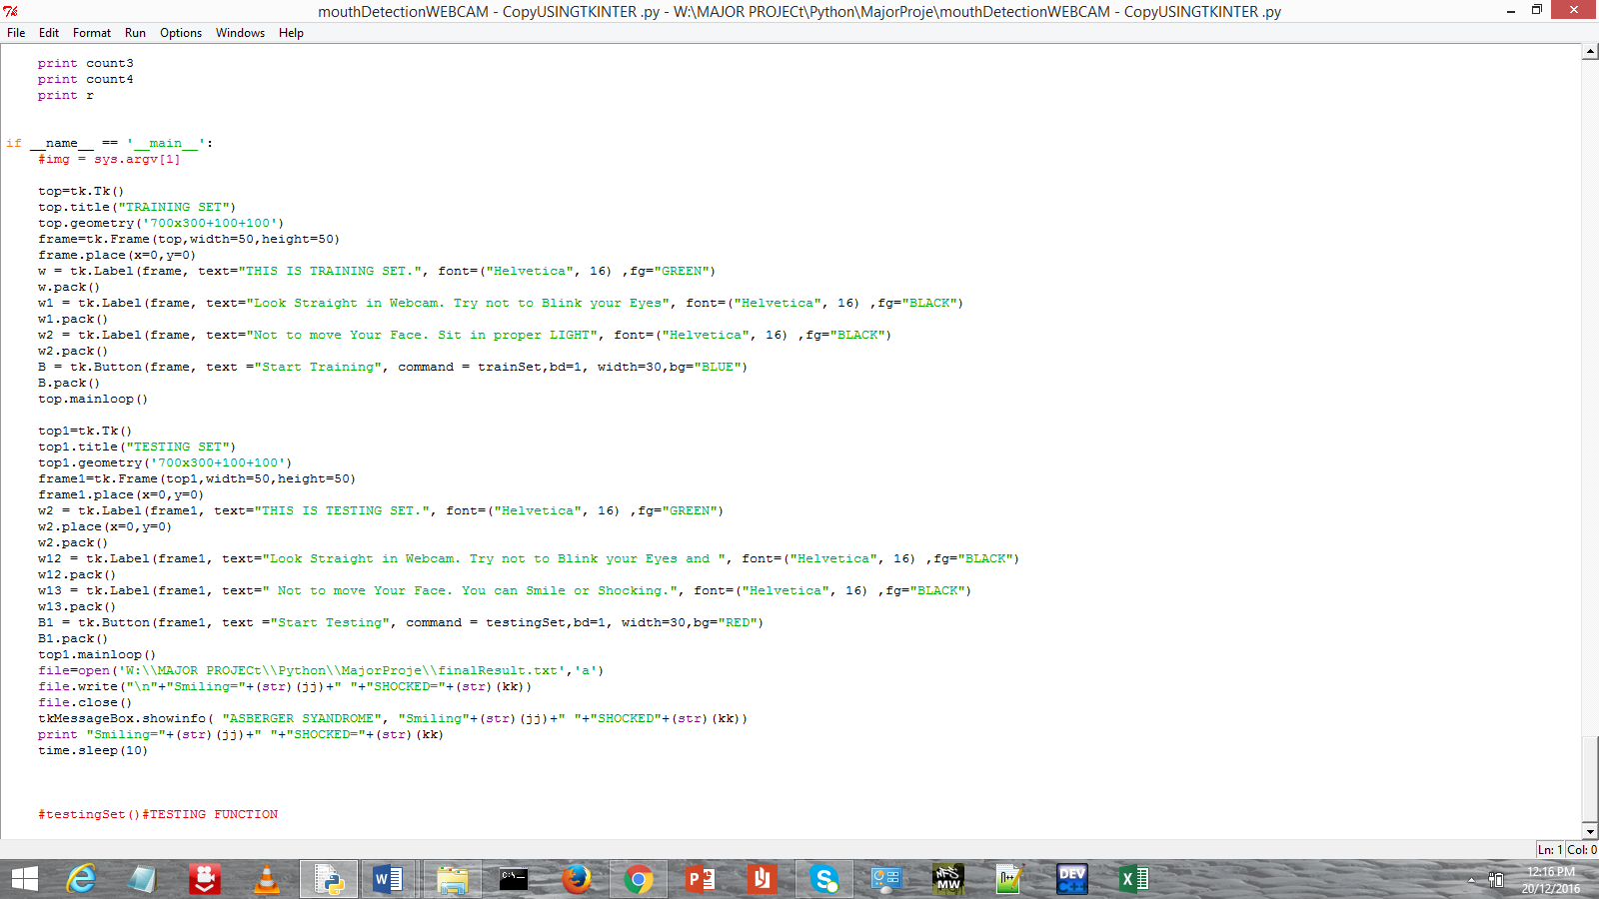

* 1. TESTING:

4.2.1 Testing Plan:-

Phase 3:



**PHASE 1 and 2:**

We decide to talk testing set of different people using webcam and detect their face using opencv and we have targeted 122 people.

4.2.2 Type of testing required: -

For testing we require person face to detect the person emotions. Here it detect face, mouth, Eyes and then check the size of person mouth/face and run it.

4.2.3 List all test cases in prescribed format: -

We run on 122 different people and make training set. Sometimes we get appropriate answer and sometime we don’t get.

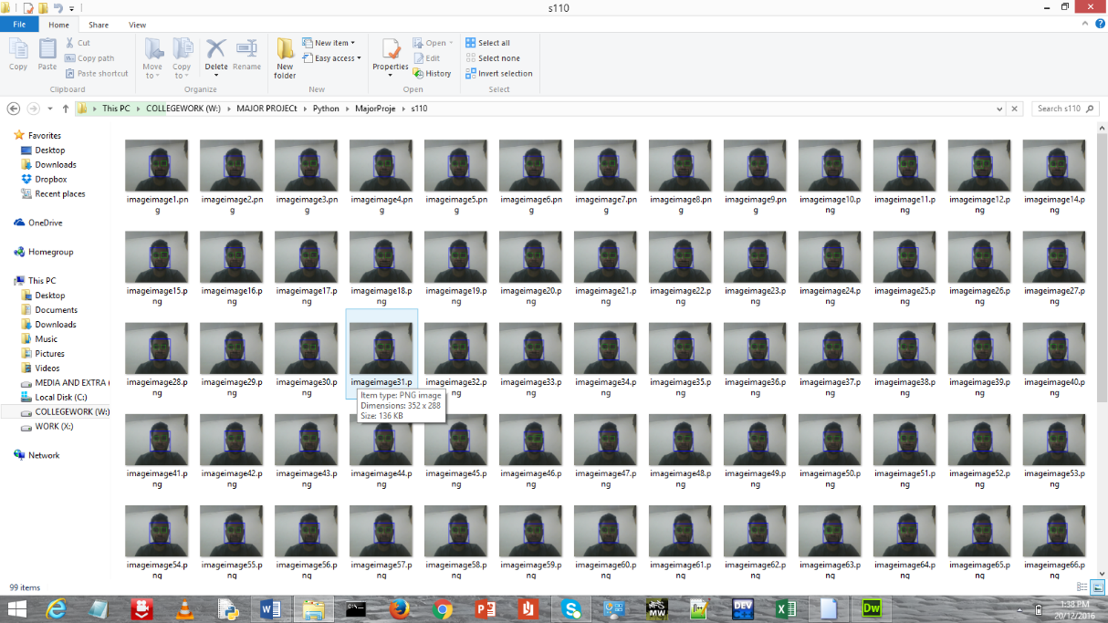

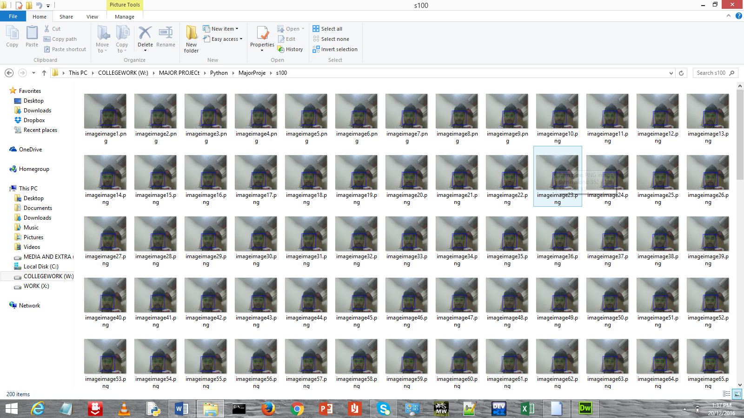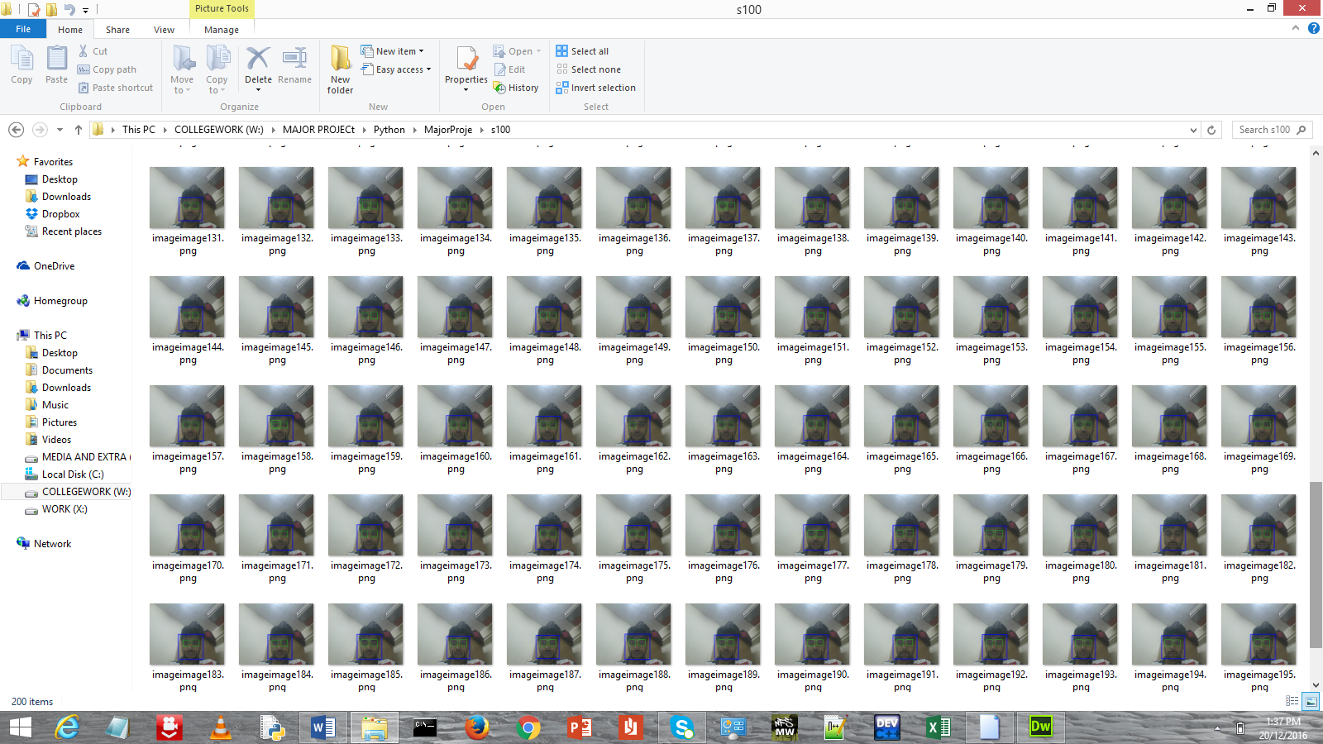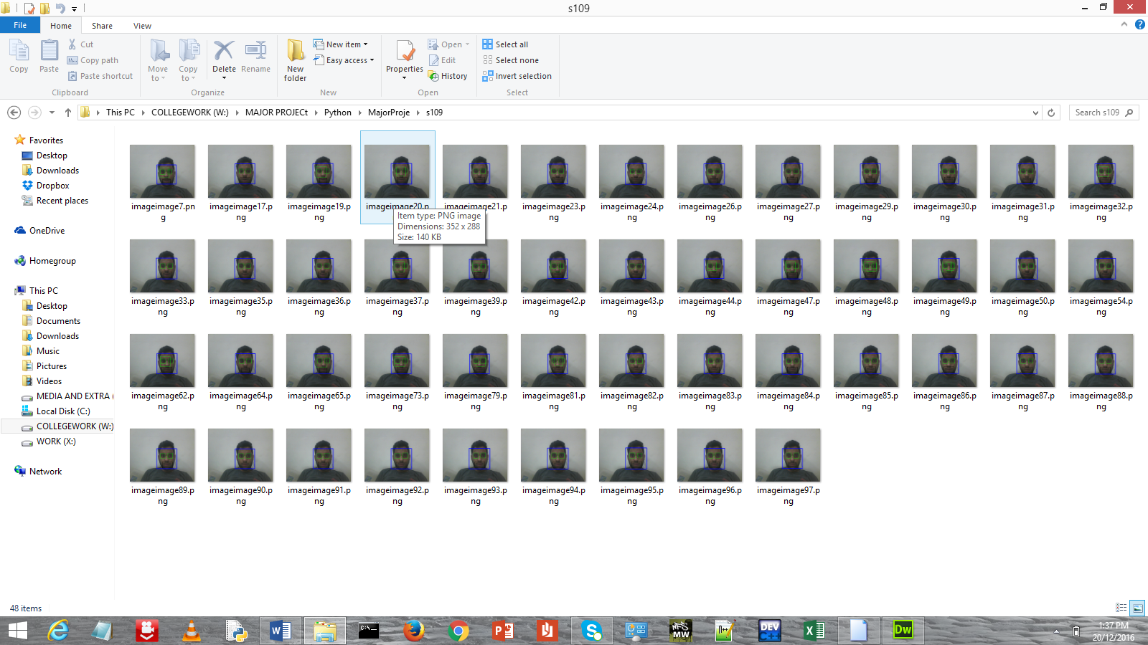

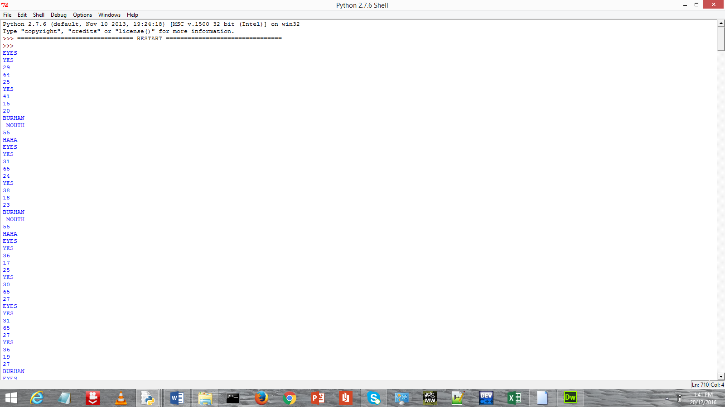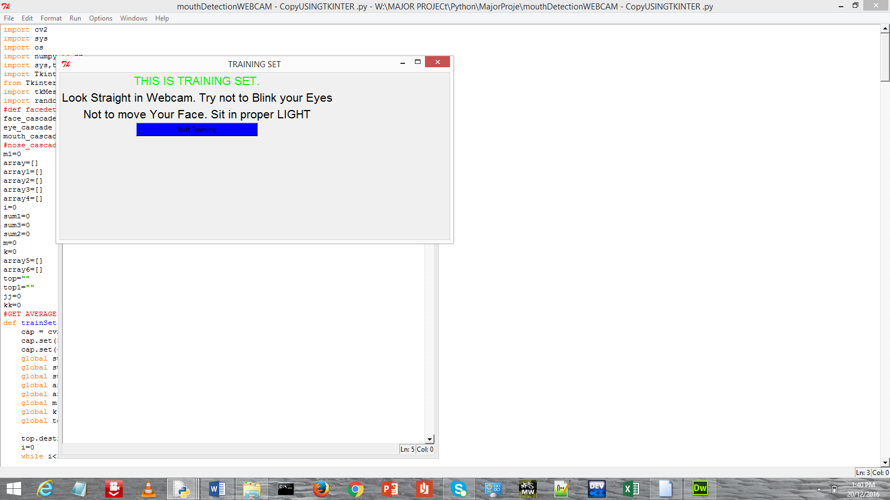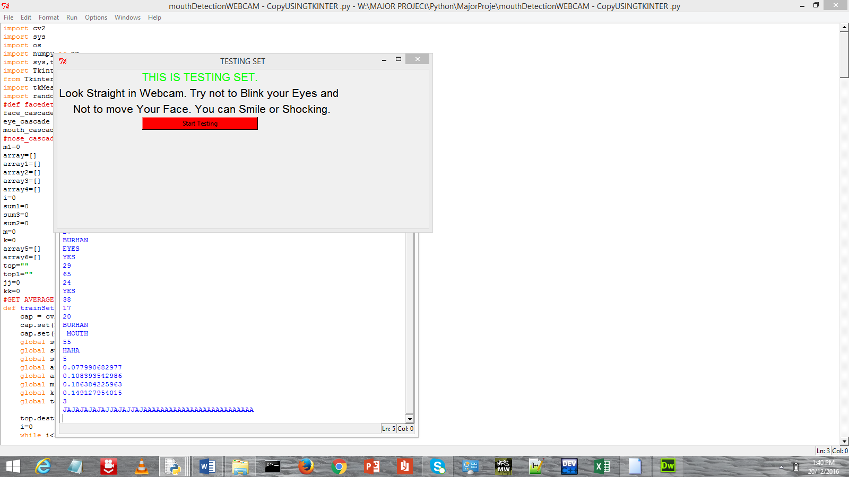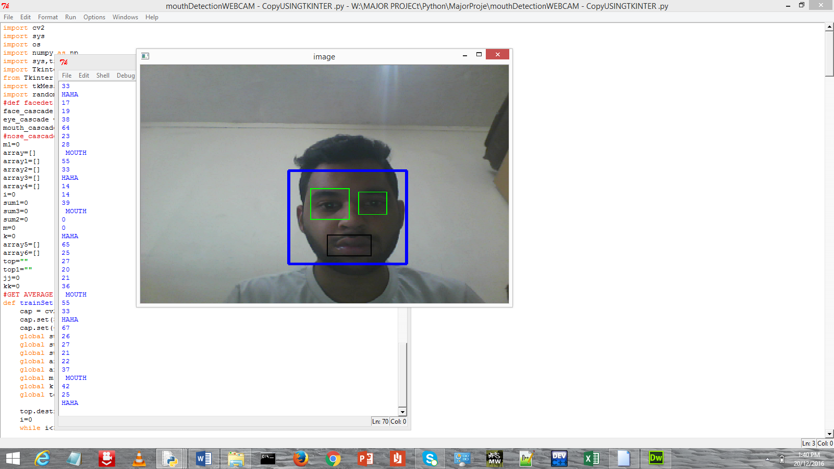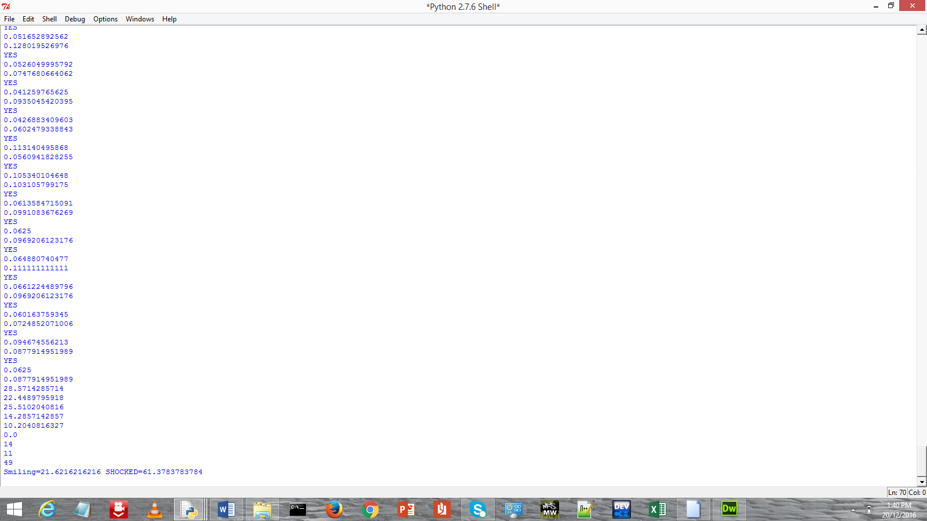

4.2.4 Limitation of Solution

1) Don’t work in Sunlight as sunlight hinder webcam to detect proper face.

2) Don’t work for heavy lips person as heavy lips are out of range for opencv and give wrong results for that

## OPEN PROBLEMS :-

1. Generating high-resolution images
2. Generating human-like speech
3. Robust analysis of video streams
4. Learning complex strategies where the state doesn’t represent all previous steps efficiently
5. Understanding natural language - most of the industry uses complex solutions for NLP tasks. they consist of several algorithms, not all of them are ANNs.
6. Question answering is also ineffective - deep architectures struggle to compete with information retrieval methods (search engine with simple indexing and a decent database performs surprisingly well)

## DIVISON OF WORK :-

* Amit Sachdeva : 1) 2 Research Paper(Image based Face

Detection and Recognition ) (An Introduction to Face

Recognization Technology)

* 1. Application ( Smile Detection and

Face Detection)

* Burhanuddin Bhopalwala : 1) 1 Research Paper (Facial

Emotion Recognition with a Neural Network Approach)

* + 1. Application (Smile

Detection)

* + 1. Android App (Edge

Detection)

* Abhinav Mishra : 1) 2 Research Paper (Edge Detection through Artificial Neural Networks) ( An Implementation Image Edge and Feature Detection

Using Neural Network )

* 1. Android App (Emotion Detection)

### RISK ANNALYSIS :-

|  |  |  |  |  |
| --- | --- | --- | --- | --- |
| Risk Id | Description | Risk Area | Impact | Risk  Selected  Mitigation |
| 1 | Our smile Recognization application not always work on every image . | Neural  Network work in limited domain | Decrease Efficiency of  Application | N |

**CONCLUSION:**

We did Image Denoising and Deblurring for increasing the Efficeincy for our previous Phase2+1 Real time dyamic image processing systems**.** We used novel restoration method is presented for both image denoising and image deblurring. The noise which is defined as the difference between degraded image and the original image should be minimized for improvement in their performance on image restoration. To first, a novel denoising method is proposed for suppression of noise at all level of noise density. Second, in deblurring method ,a new combine constraint of non-local similarity and Non-locally centralized Sparse Representation is proposedfor achieving higher performance. The reconstructed edges are much sharper and more image fine structures are recovered easily.Experimental results on image denoising, and deblurring demonstrated with proposed work, can achieve higher performance than other principal denoising and deblurring methods.

**FUTURE WORK**:

Improvements in the design and Implementation of the face detection and normalization Modules, or any extensions that could aid in the speed

And robustness of the face recognition system are Continually in demand. And also with more use of these face detecting and emotions detecting algorithms more improvements are still is under developments to achieve 90%+ Accuracy.

# APPENDIX :-

## References :-

[1] Mohamed A. El-Sayed, Yarub A. Estaiti and Mohamed A. Khafagy, “ Automated Edge Detection Using Convolutional Neural Network”in *International Journal of Advanced Computer Science and Applications, Vol. 4, No. 10, 2013*.

[2] Dingran Lu, Xiao-Hua Yu1, Xiaomin Jin1, Bin Li2,3, Quan Chen2,3, Jianhua Zhu4 “Neural Network Based Edge Detection for Automated Medical Diagnosis” in International Conference on Computer and Electrical Engineering, Dec. 2009, pp. 408-412.

[3] Shahrin Azuan Nazeer 1, Nazaruddin Omar' and Marzuki Khalid2, “Face Recognition System using Artificial Neural Networks Approach” in , Anna University, Chennai, India. Feb. 22-24, 2007. pp.420-425.

[4]